Experiment-1

1. Introduction of Operating System

Introduction of Operating System An operating system

acts as an intermediary between the user of a computer

and computer hardware. The purpose of an operating

system is to provide an environment in which a user can

execute programs in a convenient and efficient manner.

Operating System – Definition: An operating system is a

program that controls the execution of application

programs and acts as an interface between the user of a

computer and the computer hardware. A more common

definition is that the operating system is the one program

running at all times on the computer (usually called the

kernel), with all else being application programs.

An operating system is concerned with the allocation of

resources and services, such as memory, processors,

devices, and information. The operating system

correspondingly includes programs to manage these

resources, such as a traffic controller, a scheduler,

memory management module, I/O programs, and a file

system.

Operating system as User Interface –

1. User

2. System and application programs

3. Operating system

4. Hardware

Every general-purpose computer consists of the

hardware, operating system, system programs, and

application programs. The hardware consists of memory,

CPU, ALU, and I/O devices, peripheral device, and

storage device. System program consists of compilers,

loaders, editors, OS, etc. The application program consists

of business programs, database programs

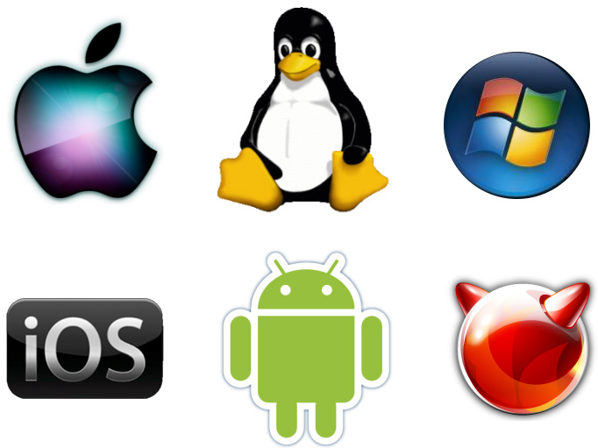

2. Functions and Services of an operating system

include:

Some key functions and services of an operating system

include:

1. Process Management: The OS manages processes

or programs running on the computer.

2. Memory Management: It handles memory allocation

and deallocation to optimize the use of the computer&#39;s

memory.

3. File Management: The OS organizes and controls

access to files stored on the computer.

4. Device Management: It interacts with hardware

devices such as printers, scanners, and storage devices.

5. Security: Operating systems implement security

measures to protect the system and its data from

unauthorized access.

6. User Interface: The OS provides a user interface that

allows users to interact with the computer system.

7. Networking: Many modern operating systems support

networking capabilities, allowing computers to

communicate with each other over networks.

These functions and services work together to ensure that

the computer system runs efficiently, securely, and

provides a seamless user experience.

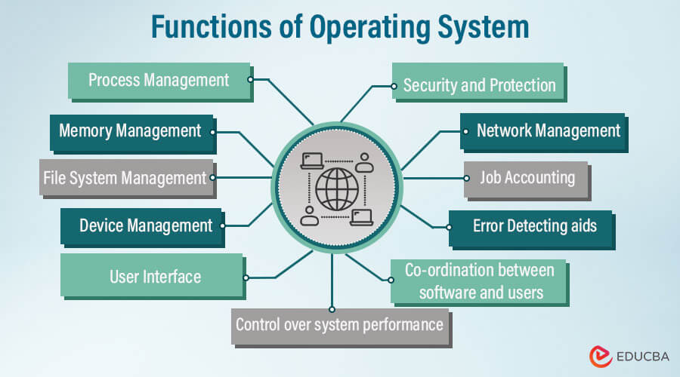

3.Needs of Operating System

Operating systems are essential for computers to function

effectively and efficiently. They fulfill various needs to

ensure the smooth operation of the system. Some of the

key needs of an operating system include:

1. Resource Management: Operating systems manage

computer resources such as CPU, memory, storage, and

input/output devices.

2. Abstraction: Operating systems provide a layer of

abstraction between hardware and software.

3. Security: OSs implement security measures to protect

the system from unauthorized access, viruses, and

malware.

4. Concurrency Control: Operating systems handle

multiple tasks simultaneously through process

management.

5. Error Handling: OSs detect and handle errors that

occur during system operation.

6. User Interface: Operating systems offer user

interfaces that allow users to interact with the computer

system.

7. File Management: OSs organize and manage files

stored on the computer. They handle file creation,

deletion, and access, ensuring data is stored securely and

Efficiently.



4.History of Linux

Linux, created by Linus Torvalds in 1991, is an open-

source operating system known for its collaborative

development model. The Linux kernel, the heart of the OS,

is freely available for modification and distribution. This

open approach has led to a diverse range of Linux

distributions tailored to different needs. Linux&#39;s popularity

stems from its stability, security, and flexibility, making it a

top choice for servers, supercomputers, mobile devices,

and embedded systems. The history of Linux showcases

the power of community-driven innovation and the

advantages of open-source software.

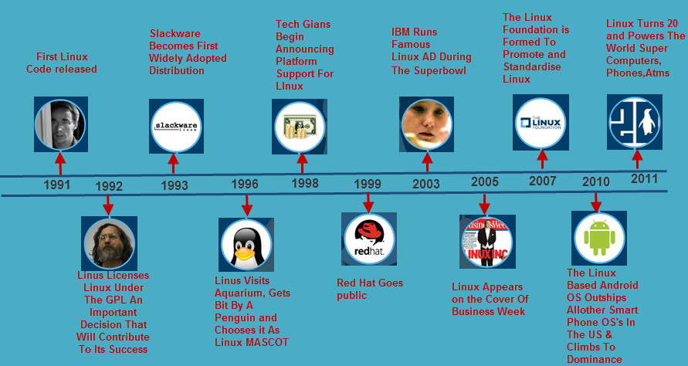

5.Different application of linux in operating system

Linux is widely used across various applications and

industries due to its versatility and reliability. Some

common applications of Linux in operating systems

include:

1. Servers: Linux is a popular choice for server operating

systems due to its stability, security features, and ability to

handle high workloads efficiently.

2. Supercomputers: Many of the world&#39;s supercomputers

run on Linux due to its scalability and performance

capabilities, making it ideal for complex computational

tasks.

3. Mobile Devices: Android, which is based on the Linux

kernel, powers a significant portion of mobile devices

globally, showcasing Linux adaptability for mobile

operating systems.

4. Embedded Systems: Linux is commonly used in

embedded systems like routers, smart TVs, and IoT

devices due to its small footprint, customization options,

and robustness.

5. Desktops and Laptops: Linux distributions like Ubuntu,

Fedora, and Debian offer user-friendly desktop

environments, making Linux a viable alternative to

traditional operating systems like Windows and macOS.

6. Cloud Computing: Linux is prevalent in cloud computing

platforms like Amazon Web Services (AWS), Google

Cloud Platform, and Microsoft Azure, providing a stable

and secure foundation for cloud services.

These are just a few examples of the diverse applications

of Linux in operating systems, showcasing its adaptability

and widespread use across different technological

domains.